**Coal lab 05**

Name: Syed Muzzamil Waseem

SID: 11067

Question 1

CODE:

INCLUDE Irvine32.inc

.data

mess1 BYTE "Enter any Number: ",0

mess BYTE "*",0

num1 dword ?

num2 dword 1

.code

main Proc

mov edx,offset mess1

call writestring

call readint

mov num1,eax

mov ecx,1

.while ecx <= num1

mov eax,ecx

mov ebx,1

.while ebx <=num2

call writedec

inc ebx

.endw

call crlf

inc num2

inc num2

mov edx,offset mess

mov ebx,1

.while ebx <= num2

mov edx,offset mess

call writestring

inc ebx

.endw

inc num2

inc num2

call crlf

inc ecx

inc ecx

.endw

exit

main ENDP

END main

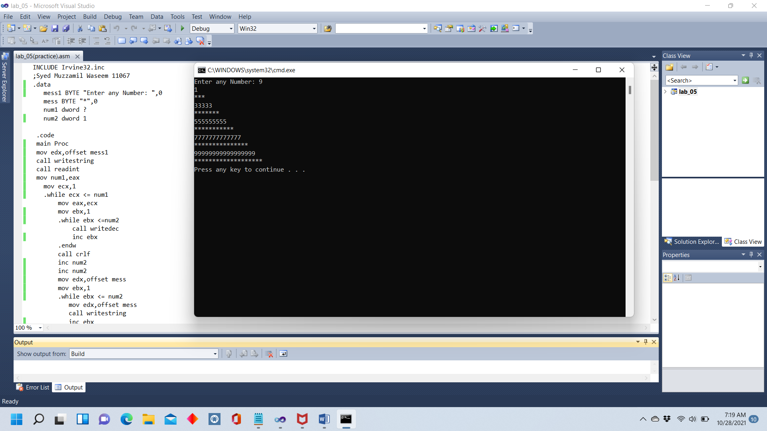

Question 2

CODE:

INCLUDE Irvine32.inc

.data

;Syed Muzzamil Waseem 11067

var1 dword ?

var2 dword 1

var3 BYTE "*"

blank BYTE " "

.code

main PROC

Call ReadInt

mov var1, eax

Call crlf

mov esi, var1

mov ecx, 1

.WHILE ecx <= var1

mov eax, ecx

mov edx, offset blank

mov ebx, esi

.WHILE ebx >= 1

Call WriteString

dec ebx

.endw

dec esi

mov ebx, 1

.WHILE ebx <= var2

Call WriteDec

inc ebx

.endw

call crlf

inc var2

inc var2

mov edx, OFFSET blank

mov ebx, esi

.WHILE ebx >= 1

Call WriteString

dec ebx

.endw

dec esi

mov edx, OFFSET var3

mov ebx, 1

.WHILE ebx <= var2

Call WriteString

inc ebx

.endw

inc var2

inc var2

Call crlf

inc ecx

inc ecx

.endw

exit

main ENDP

end main

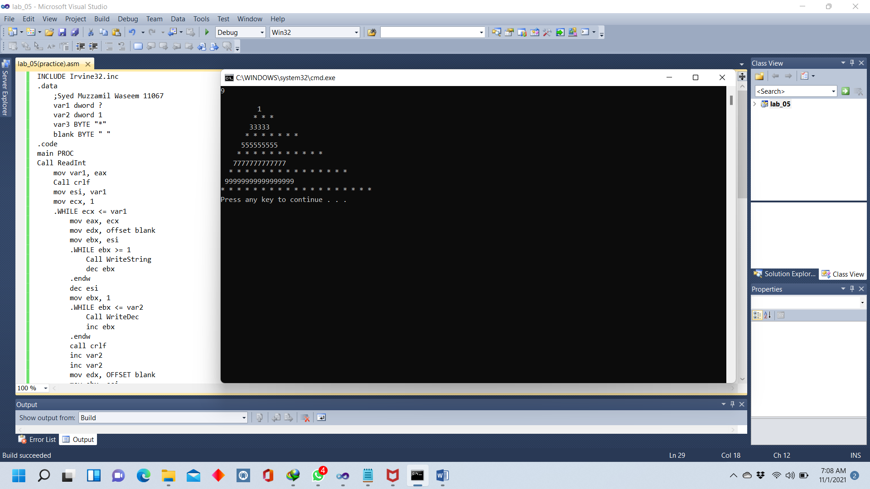

Question 3

CODE:

Include Irvine32.inc

.data

;Syed Muzzamil Waseem 11067

msg byte "Enter the range: ",0

star1 byte "*",0

star2 byte " ",0

num1 dword ?

num2 dword ?

n1 dword ?

n2 dword ?

.code

main PROC

mov edx, offset msg

call writestring

call readint

mov num1, eax

mov ecx,1

mov eax, 1

mov num2, ecx

.while ecx <= num1

mov ebx,1

.while ecx <= num1

mov edx,offset star2

call writestring

inc ecx

.endw

mov ecx, eax

cmp ecx,1

JE child1

add num2,2

child1:

.while ebx <= num2

mov edx,offset star1

call writestring

inc ebx

.endw

inc eax

inc ecx

call crlf

.endw

mov ecx, num1

sub ecx,1

mov n1,2

.while ecx >= 1

mov eax,1

.while eax <= n1

mov edx, offset star2

call writestring

inc eax

.endw

mov n2, ebx

sub ebx, 3

.while ebx >= 1

mov edx, offset star1

call writestring

dec ebx

.endw

mov ebx, n2

sub ebx, 2

inc n1

dec ecx

call crlf

.endw

exit

main ENDP

END main

